Definition of the Selectet Message Pane
Menu Bar
Toolbar
Defined Messages Pane
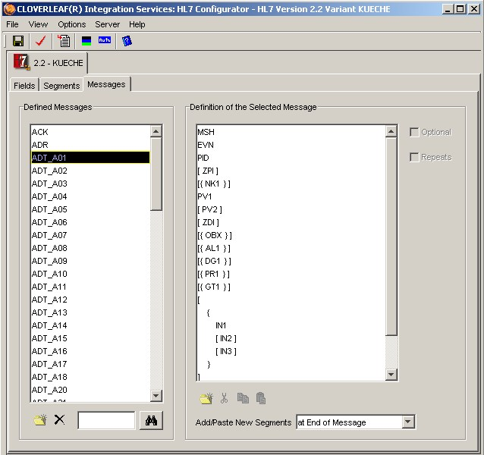
New
Delete
Find
Add Cut Copy Paste Position

